DET- VTIS

Test Plan for Stage 3 System Testing

**Version 0.2**

DOCUMENT DETAILS

|  |  |  |  |
| --- | --- | --- | --- |
| **Date Created** | 24/10/2017 | **Last Modified Date** | 06/11/2017 |
| **Created By** | Shilpa Nerasu | **Version** | 0.2 |

AMENDMENT HISTORY BLOCK

| Version Number | Description of Change | Person Making Change | Date |
| --- | --- | --- | --- |
| 0.1 | Initial draft | Shilpa Nerasu | 24/10/2017 |
| 0.2 | Incorporated Feedback from Yohan | Shilpa Nerasu | 6/11/2017 |
|  |  |  |  |
|  |  |  |  |
|  |  |  |  |
|  |  |  |  |
|  |  |  |  |
|  |  |  |  |
|  |  |  |  |

TEMPLATE VERSION HISTORY

| Template Version Number | Person Making Change | Date |
| --- | --- | --- |
| V0.2 | Shilpa Nerasu | 6/11/2017 |

Distribution List

| **Name** | **Organisation** | **Title** | **Distribution Method** |
| --- | --- | --- | --- |
| Kolitha Dassanayake | NEC | Project Manager | Email-Review |
| Yohan Karunathilaka | NEC | Program Test Manager | Email-Review |
| Raja Balakrishnan | NEC | Solution Architect | Email-FYI |
| Michael Thompson | NEC | Delivery Architect | Email-Review |
| Nicholas Taylor | NEC | Technical Lead | Email-FYI |
| Richard Zhao | NEC | Functional Lead | Email-FYI |
| Ryan D’Souza | NEC | Data and Integration Lead | Email-FYI |
| Owen Mckenna | NEC | Consultant | Email-FYI |
| Scott Che | NEC | Consultant | Email-FYI |
| Peter Maynard | DET | Test Manager | Email-Review |
| Chris Sanderson | DET | Project Manger | Email-Review |
| Rav S Bains | DET | Transition Manager | Email-Review |

Document Acceptance (Client)

| **Name** | **Organisation** | **Title** | **Signature** | **Date** |
| --- | --- | --- | --- | --- |
| Peter Maynard | DET | Test Manager |  |  |
| Nikhil Police | DET | Account Manager |  |  |

Reference Documentation

This document references the following documents:

|  |  |  |
| --- | --- | --- |
| **Actual document** | **Document name** | **Location** |
| Functional specification | [VTIS Functional Specification Stage 3 v0.1.docx](https://devtools.nec.com.au/wiki/download/attachments/4947973/VTIS%20Functional%20Specification%20Stage%203%20v0.1.docx?api=v2) | Confluence -> Documents -> Functional Specification -> Stage 3 |
| Technical specification | <Yet to be provided> | Confluence -> Documents -> Technical Specification -> Stage 3 |
| Project Test Strategy | <https://edugate.eduweb.vic.gov.au/edrms/collaboration/TMIA/NEC%20LIBRARY/Testing/NEC%20Test%20Strategy%20for%20DET-VTIS%20V2.0.docx> | DET SharePoint |
| Victorian VET statistical guidelines | [(VVSSCG) Victorian VET Student Statistical Collection Guidelines - 2016.pdf](https://onebox.nec.com.au/wiki/download/attachments/2916615/%28VVSSCG%29%20Victorian%20VET%20Student%20Statistical%20Collection%20Guidelines%20-%202016.pdf?api=v2) | Confluence -> Documents ->  [Build](https://onebox.nec.com.au/wiki/display/VDE/Build?src=breadcrumbs-expanded) ->  [Architecture Design](https://onebox.nec.com.au/wiki/display/VDE/Architecture+Design?src=breadcrumbs-parent) |
| Shakeout testing document | [DET TMO QA Environment Solution Shakeout Guide v0.1.docx](https://onebox.nec.com.au/wiki/download/attachments/2916414/DET%20TMO%20QA%20Environment%20Solution%20Shakeout%20Guide%20v0.1.docx?api=v2) | Confluence -> Documents ->  QA |
| RTM | [Master RTM v1.1.xlsx](https://onebox.nec.com.au/wiki/download/attachments/2916481/Master%20RTM%20v1.1.xlsx?api=v2) | Confluence -> [DET Final Deliverables to NEC](https://onebox.nec.com.au/wiki/display/VDE/DET+Final+Deliverables+to+NEC) |

Contents

1 Introduction 7

1.1 Background 7

1.2 Stage 3 Overview 7

1.2.1 Manage Funding Contracts (Manage Stakeholder) 8

1.2.1.1 Establish and Initiate Funding Award Period 9

1.2.1.2 Complete Application and Prepare for evaluation 9

1.2.1.3 Evaluate and Award Funding Contract 9

1.2.1.4 Manage Funding Contract 10

1.2.2 Manage External Engagement 10

1.2.2.1 Handle Interactions 10

1.2.2.2 Conduct Quality Surveys 10

1.2.2.3 Process Communications 11

1.2.2.4 Organize and conduct reviews 11

1.2.3 Manage Funding Program 11

1.2.3.1 Manage Training Products 12

1.2.3.2 Maintain Validation and Payment Rules 12

1.2.4 Manage Compliance and Performance 12

1.2.4.1 Conduct Contract Compliance Audits 13

1.2.4.2 Perform Investigations and Enforce Contract Compliance 13

1.3 Purpose of Document 13

1.4 Audience 14

1.5 Document Scope 14

1.5.2 Scope Inclusions 14

1.5.3 Scope Exclusions 15

1.6 Assumptions 15

1.7 Dependencies 15

1.8 Constraints 16

2 Milestones 17

2.2 Testing Schedule 17

3 Testing Scope 17

3.1 Test Items in Scope 17

3.1.1 CRM Components 17

3.1.2 Functional Requirements 17

3.1.3 Technical Specification 17

4 System Testing Approach 18

4.1 Risk-based Testing 19

4.2 Test Estimation 19

4.3 Test Requirements 19

4.4 Requirements Traceability Matrix 19

4.4.2 Test Requirements Traceability Matrix 19

4.5 Test Cases 19

4.6 Test Data Preparation 20

4.7 Test Execution Cycles 20

4.8 Item Pass/Fail Criteria 21

4.8.2 Functionalities in Functional specification and Technical specification 21

4.9 Suspension Criteria and Resumption Requirements 22

4.9.2 Test Suspension Criteria: 22

4.9.3 Test Resumption Criteria 22

4.10 Raising and Retesting Defects 22

4.11 System Test Entry and Exit Criteria 24

4.12 Test Signoff 25

4.12.2 System Testing Acceptance Criteria 25

4.13 Test Deliverables 25

4.14 Testing Tools 25

5 Delivery Stages 25

6 Test Phases 25

6.1 Sprint Testing 25

6.2 System Testing 26

6.3 Regression Testing 29

6.4 Post-Implementation / Production Verification Testing 29

6.5 Non Functional Testing 30

6.5.2 Accessibility Testing 30

6.5.3 Browser Compatibility Testing 31

6.5.4 Performance Testing 32

7 Environmental Requirements 32

7.1 Environments 32

7.2 Technical Support 32

8 Defect Management 33

9 Roles and Responsibilities for Stage 3 System Testing 33

9.1 Staffing needs 33

9.2 Status Meetings and Reporting 33

10 UAT Support 34

11 Risks and Contingencies 34

11.1 Risk and Issue Management 34

11.2 Lessons Learnt 34

12 Appendix 34

12.1 Acronyms 34

2. Introduction
   1. Background

The Training Market Operations Division (TMO) sits within the Higher Education and Skills Group (HESG) in DET. The TMO develops entry to market and contracting standards, contracts, funds and quality assures government subsidised vocational education and training (VET) providers. It also develops and maintains the Group’s business systems including the management of training activity information.

A demand driven model was introduced to the Victorian Vocational and Education Training Market in 2009 and phased in over three years to 2012. This reform required the Department to collect training data from training providers, validate data and process claims for payment based on new funding rules.

The allocation and tracking of funding allocations according to eligibility rules is predominantly managed by the TMO team who use the following two business systems:

Skills Victoria Training System (SVTS) – focusing on claims processing and data collection

Skills Victoria Business Intelligence (SVBI) – focusing on analytical reporting

* 1. Stage 3 Overview

This functional area focuses on the funding contracts, external engagement, funding programs and compliance and performance.

Each solution is broken up into key areas. Outlined below are the key areas for each solution component.

Manage Funding Contracts is broken up into three key areas:

1. Establish and Initiate Funding Award Period
2. Evaluate and Award Funding Award Period
3. Manage Funding Contracts

Manage External Engagement is broken up into four key areas:

1. Handle Interactions
2. Conduct Quality Surveys
3. Process Communications
4. Organize and Conduct Events

Manage Funding Programs is broken up into two key areas:

1. Maintain Training Products
2. Maintain Validation and Payment Rules

Manage Compliance and Performance is broken up into three areas:

1. Conduct Contract Compliance Audits
2. Perform Investigations
3. Enforce Contract Compliance

Figure 1: The following diagram highlights stage 3

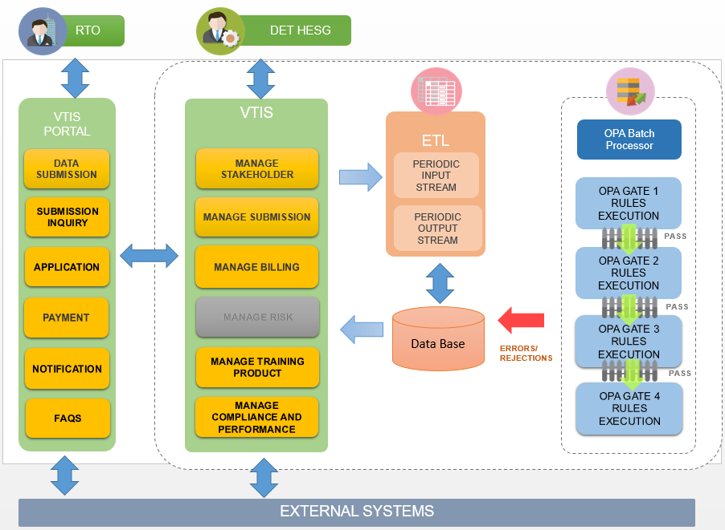

* + 1. Manage Funding Contracts (Manage Stakeholder)

This function focuses in creation and management of contracts with RTO’s and tracks all communication to and from stakeholders and will provide a mechanism for RTO’s to submit additional information relating to their training delivery.

The key stakeholder groups for The Department are: Registered Training Organisations (RTOs) and Students. The Department may also look into managing information relating to other groups such as third-party trainers, teachers and employers.

1.2.1.1 Establish and Initiate Funding Award Period

This function focuses on the establishment of new funding contracts within The Department and publishing the invitation for EOI to the RTO market. Prior to this process, RTOs are required to register either with the Australian Skills Quality Authority (ASQA) or with the Victorian Registration and Qualifications Authority (VRQA). Once registered, this process imports RTO registration details and conducts a series of assessments on the RTO to ensure the RTO meets the training delivery requirements set by The Department.

Invited RTOs who wish to deliver training against the new funding contract can then seek additional information from The Department prior to submitting their EOI (contract application). This function includes developing the contract application framework, determining the RTO participation list, publishing the EOI invitation to the RTO participation list and managing EOI application enquires.

Once approved, the RTO will be issued a contract to allow commencement of training delivery and funding.

* + - 1. Complete Application and Prepare for evaluation

Prior to this process, a new funding period has been established and the training market has been invited to submit expressions of interest through an online application process.

This function includes the description of processes associated to an RTO completing an online application and the receipt of this application by the Department in preparation for evaluation.

It also includes the submission of detailed training plans and the completion of a financial assessment.

* + - 1. Evaluate and Award Funding Contract

Prior to this process, RTOs are required to register either with the Australian Skills Quality Authority (ASQA) or with the Victorian Registration and Qualifications Authority (VRQA). Once registered, this process imports RTO registration details and conducts a series of assessments on the RTO to ensure the RTO meets the training delivery requirements set by The Department. This process incudes evaluation of the information provided by the RTO as part of their EOI submission. Once approved, the RTO will be issued with a contract to allow commencement of training delivery and funding.

* + - 1. Manage Funding Contract

This function focuses on the on-going management and maintenance of RTO contracts including amendments, renewals and terminations of contract. The contract management process will proceed through a number of steps to revise or terminate the contract and inform the RTO accordingly. In addition, this function also provides a mechanism by which RTOs can provide additional information (outside of the monthly VVSSCG files) to either comply with specific contractual requirements, or contribute optional information relating to programs such as the Victorian Training Select and Skills Gateway programs

* + 1. Manage External Engagement

The Manage Stakeholder function focuses on the creation and management of contracts with RTOs and aggregation of information relating to The Department’s stakeholders. The Department manages agreements with RTOs and provides funding for the training delivered at contracted RTOs. This function will track all communication to and from stakeholders and will provide a mechanism for RTOs to submit additional information relating to their training delivery.

The key stakeholder groups for The Department are: Registered Training Organisations (RTOs) and Students. The Department may also look into managing information relating to other groups such as third-party trainers, teachers and employers.

* + - 1. Handle Interactions

This function focuses on recording stakeholder queries or complaints that have been made directly to The Department. A stakeholder in this regard may refer to a student, RTO or Other category (e.g. Parent, Employer, former employee, etc.). This process will capture the details of the query or complaint in the form of a ticket, and assign the ticket to the relevant users to respond and resolve. All contacts with stakeholders are logged, and the status of open tickets is actively monitored and escalated where required. Once a ticket has been resolved, the outcome is recorded.

It is envisaged that the system will support a variety of ticket categories as described in the following diagram. Note: the diagram below is for conceptual purposes. The number and description of ticket categories may vary during implementation

* + - 1. Conduct Quality Surveys

This function focuses on conducting pre-defined surveys with a selected cohort of students and RTO’s. The cohort may be part of a random sample or based on a selected RTO due to an open investigation. The function will maintain a series of survey templates that can be used to measure the quality of training, accuracy of reported data or for other statistical purposes. Surveys can be conducted on various available channels including emails, phone calls, and SMS (optional). The outcome of student surveys is recorded against the risk profile for the RTO.

* + - 1. Process Communications

This function focuses on The Department’s communication to RTOs (through Stakeholder Notification (CNs)) and other external parties. The Department will be able to manage a suite of templates to inform typical notification messages (e.g. changes to hourly subsidy rates) and also select which RTOs the notification is sent to. In addition, the Department may seek confirmation that the notification has been received and understood through an acknowledgment process step.

* + - 1. Organize and conduct reviews

The Organize and Conduct Events function focuses on the creation, invitations, and management of information events for an RTO. Events are typically conducted throughout the year focusing on: Provider selection process, on-boarding of new RTOs and end of year data collection processes. The Department may choose to survey other events based on ad hoc requirements.

Events can be targeted to specific RTOs within a region, type (e.g. TAFE / Non-TAFE) or other criteria. Each event can have multiple sessions at different times and/or locations

* + 1. Manage Funding Program

The Manage Funding Programs function focuses on the product management lifecycle of training products (units and Training Programs), the management of Training Programs that RTOs are permitted to deliver and receive government funding for and the rates at which these are funded. The key activities include phasing-in new training products, reviewing market demand across the regions in Victoria, managing funding rates and associated payment calculation requirements and phasing out training products. Any changes to training products are typically communicated to the RTOs in the form of a Customer Notification (CN).

Part of managing funding programs includes management of the reference data and logic that sit behind Funding Programs. This includes topics such as ending training programs, RTO funding eligibility, maintenance of subsidies, concessions and fee waivers and delivery contract restrictions. This also includes maintaining reference and master data through external data feeds, RTO updates and internal updates.

* + - 1. Manage Training Products

This function focuses on the management and maintenance of training products approved for delivery in Victoria. It includes managing the tasks to add, remove or update training products, update details or subsidies and informing the RTOs of the subsequent changes.

The key trigger for this activity is the update of training products from the training.gov.au (TGA), STAR / National Register CRM or DELTA / EPSILON. Updates may also be made within DET based on business decisions on funding and subsidy rates or as a result of certain RTO enquires

* + - 1. Maintain Validation and Payment Rules

This function manages the full set of required file validation rules that result in the errors or warning on received files. These rules are to be fully maintainable and configurable and will be run at various stages of the submission process.

Validation rules arise through the policy and regulatory framework set by The Department informing the eligibility for funding. The validation rules are communicated in the VVSSG document that details acceptable data standards and reason codes for warnings and rejections. In addition, validation rules involve checking the data against other files and fields The Department has access to (e.g. DELTA / EPSILON).

This function also focuses on the maintenance of Payment Calculation rules that result in amounts payable to RTOs. Payment calculation rules arise through the set funding rules established by The Department and could involve other complexities such as weightings and premiums.

* + 1. Manage Compliance and Performance

The Manage Compliance and Performance function focuses on a range of activities to ensure RTOs are compliant to the agreed contractual requirements. These activities include performing regular contract assurance activity in the form of compliance audits, investigating suspected contract non-compliance and enforcing contract compliance.

These activities may be triggered by an escalated complaint, ministerial directive or when a RTO risk profile has reached a predefined threshold.

* + - 1. Conduct Contract Compliance Audits

This function focuses on the activities supporting the audit of RTOs. Audits may be conducted as part of the annual schedule, identifying those RTO’s that potentially present a greater risk of non-compliance with the Skills First VET funding contract, or triggered by matters which come to the attention of the Department throughout the year.

The supporting activities include creating an audit record, assigning it to a user, logging communication and file notes, and the status of open records are actively monitored and escalated where required. Once an audit has been concluded, the outcome is recorded

* + - 1. Perform Investigations and Enforce Contract Compliance

This function focuses on the key activities that involve the investigation of issues pertaining to an RTO and any action that may be required to enforce compliance.

An investigation may arise when an RTO is suspected of contract non-compliance. This may be triggered by a complaint, information received about an RTO, audit finding, review of RTO data analytics or when an external event has triggered concerns.

The supporting activities include capturing the details of the investigation in the form of an investigation record, assigning the investigation record to the relevant users and concludes with an outcome.

All contact with RTO’s are logged, and the status of open investigations is actively monitored and escalated where required. Once an investigation ticket has been resolved, the outcome is recorded.

The outcome of an investigation may produce an escalation of the matter, in which contract enforcement activity will need to proceed. Contract enforcement can also be initiated through notices of insolvency.

* 1. Purpose of Document
* To define the scope of System Testing for Stage 3
* Approach that will be used to test the functionality
* Deliverables from the QA team
* Testing techniques used and approach implemented
* Tools
* Staffing and Responsibilities
* Schedule
* UAT support
* Risks and Contingencies
  1. Audience

Please refer to the section “Document Review, Approval & Distribution List” of this document

* 1. Document Scope

The scope of this document is for Stage 3 System Testing only; other types of testing are out of scope for this document.

* + 1. Scope Inclusions

The scope of system testing in Stage 3 covers the following:

* Stage 3 Functionalities stated in Functional Specification (currently in draft stage)
* Manage Funding Contracts
* Manage External Engagement
* Manage Funding Programs
* Manage Compliance and Performance
* Technical specification (currently in draft stage)
* CRM integration flow
* ECP integration with Portal and CRM (carried forward from Stage 1)
* Reports (carried forward from Stage 1) (6 more reports to be confirmed)
* Enrolment Activity
* Student Exemption Summary
* Course Report
* Module Report
* Qualification Report
* Outcomes
* Payment History
* Forecast Cashflow
* Enrolment Status
* Claim Confirmation
* Review Caims
* Claims to be paid
* Claim Status
* Claim Detail
* Scope Of registration
* Accessibility testing of Portal & CRM (listed in sec 6.5 of this document)
* Browser Compatibility testing (listed in sec 6.5 of this document)
* Regression testing of only impacted areas of stage-1 & stage-2 requirements.

Please refer the Assumptions section for exact scope of these documents.

* + 1. Scope Exclusions
* Complete regression of stage-1 and stage-2 requirements(Stage-3 requirements are CRM specific changes and there will be low impact on Stage-1 and Stage-2 requirements)
* Load testing with concurrent /distributed users is out of scope of this testing
* Any type of testing other than System Testing and Accessibility Testing
  1. Assumptions

| Item | Assumption |
| --- | --- |
| TA01 | All CRM components in scope will be tested. |
| TA02 | Performance testing is not in scope for stage-3 testing. |
| TA05 | The test team has reviewed the Functional and given it is a WIP document, the test scope for stage 3 is derived with the current version available  VTIS Functional Specification Stage 3 v0.1.docx (currently in draft stage)  VTIS Technical Specification Stage is yet to be published |

* 1. Dependencies

Successful completion of testing for Stage 3 is dependent on the following:

| Item | Dependency |
| --- | --- |
| TD01 | Functional Specification should be finalised (or agreed that test cases will be built based on a particular version) |
| TD02 | Technical Specification should be finalised (or agreed that test cases will be built based on a particular version) |
| TD03 | CRM functionalities fully delivered to System test team in order to perform system testing |
| TD04 | The core functionality specified in functional specification document must be delivered before system testing begins |
| TD05 | Test environment should be available and accessible by both onshore and offshore teams |
| TD06 | The list of reports approved by DET are built by the Dev team |
| TD07 | Stage-1 & Stage-2 testing to be completed for any dependant requirements to test in stage-3. |

* 1. Constraints

Test execution will be performed with reference to the below constraints identified as of the writing of this test plan

1. Data migration: Test data may not be available in all master tables as needed, as the data from the current SVTS system database is not yet fully migrated to the VTIS system database. Therefore, where needed, test data is currently created by seeding data into the NAT files by the system test team
2. Functional Specification updates: Functional Specification is currently undergoing changes based on the clarifications obtained from DET and hence as per Agile approach the test cases for such functionality are based on

* Functional Specification
* JIRA Story’s
* Workshops
* Showcase provided by developers

1. Milestones

Please refer to the project plan for milestone details

* 1. Testing Schedule

Latest project schedule at the time of preparing this test plan can be found here.



1. Testing Scope
   1. Test Items in Scope

3.1.1 CRM Components

The functional testing focuses on areas- funding contracts, external engagement, funding programs and compliance and performance.

* + 1. Functional Requirements

Based on the details available in the functional specification being referred in this document, descriptive test cases for each section will be created with a clear cross reference to the corresponding section of the functional specification.

* Functional Requirements
* Use Case scenarios
  + 1. Technical Specification

Some of the business requirements may not possibly be covered in the above two sections; any such requirements will have a reference to the technical specifications. For those functionalities, test cases will be derived from the Technical specification with a clear cross reference to the section it is referred against. The QA team will require assistance from development team to execute test cases if any pre-configuration is required which cannot be done at the user interface level.

1. System Testing Approach

System Testing will be based on the below mentioned approach/techniques for each stage (with possible tailoring as needed at every stage)

Black box testing will be implemented for Stage 3 functionality i.e. the Test Cases will have set of steps/input conditions and expected output and the internal workings of the system are not known to the user.

Test Cases will be derived based on the functional specification, technical specifications.

**Smoke Testing:**

Whenever a build is deployed into the test environment, the system test team will perform Smoke Testing to verify that the system satisfies the basic conditions to begin a thorough testing cycle.

The set of test cases to be executed as part of Smoke Testing can be found in TestRail. The current set of smoke test cases are given below for quick reference. This may be improvised as needed:

* Verify that the portal is available and the user can login
* Verify that the user can upload files to the portal
* Verify that Validation History and Reports are generated and can be viewed
* Verify that the CRM system is available and the user can login
* Verify that the DET user can login to the CRM system
* Verify that the DET user can search the RTOs and view details
* Verify that the submissions made in the portal are available under the corresponding RTO’s profile

The process to be followed to release a build to testing is summarized in the steps below:

The development team notifies the project management and test teams about the deployment schedule prior to commencing a deployment (typically about 4-5 hours)

The test environment will not be accessed by the test team during the deployment window

The development team deploys the code to the test environment and notifies the test team when the system is ready to be tested

System test team performs a smoke test of the environment and notifies the development team in case of any issues

Otherwise, begins a full system testing

Once the Internal testing is complete, NEC will communicate with DET to agree on a window to do the deployment of the system to UAT environment

The deployment process consist of both automated and manual steps depending on the components deployed to UAT environment

Once the deployment is done a smoke testing will be done to make the sure the build deployed is not broken and that the main functionalities of the system is working as expected

Once the smoke test is complete the System Test Lead will communicate to DET that the UAT environment is ready for UAT testing

A daily triage meeting will take place between NEC team and DET to discuss on any issues found during UAT testing. If any of these issues are blockers for testing they will be addressed immediately and a fix will be deployed to UAT environment with the agreement of DET. For any other issues the action plan will be agreed between NEC and DET during the defect triage meeting.

* 1. Risk-based Testing

Refer to the latest System Test Strategy document for this section.

* 1. Test Estimation

The attached estimation sheet will provide an insight into the method adopted in order to arrive at an estimate for the test effort for Stage 3 System



* 1. Test Requirements

Refer to the latest System Test Strategy document for details on this section

* 1. Requirements Traceability Matrix

RTM is located in Confluence -> ‘[DET Final Deliverables to NEC](https://onebox.nec.com.au/wiki/display/VDE/DET+Final+Deliverables+to+NEC)’ directory.

* + 1. Test Requirements Traceability Matrix

A new column “Test Case Id” will be added to the RTM table and relevant test cases will be mapped against the corresponding business requirements.

* 1. Test Cases

Test cases for Stage 3 System Testing will be authored in TestRail. These test cases can be viewed by logging in to TestRail with a valid user name and password

* 1. Test Data Preparation

Test Data attached to the test cases in TestRail. This can be viewed by logging in to TestRail with a valid user name and password

* 1. Test Execution Cycles

The below pictures represent the approach to be following during Stage 2 system testing

* 1. Item Pass/Fail Criteria
     1. Functionalities in Functional specification and Technical specification
* Use cases in functional specification have an outcome specified and the same will be made as the expected outcome for any referenced test cases.
* Any deviation will be reported as a defect and will be linked against the test case in TestRail.
* Test cases derived from any other section of functional specification such as wire frame or technical specification will have an expected result as specified in the documents where it has been referenced from.
  1. Suspension Criteria and Resumption Requirements
     1. Test Suspension Criteria:

Test Suspension Criteria specify the conditions under which all or a portion of the testing activities may need to be suspended. Stage 3 system testing may be suspended if one or more of the below conditions are encountered:

* When any of the interdependent systems such as Portal, CRM, OPA etc.
* When there are show stopper defects
* The environment is not stable resulting inconsistent and/or incorrect test results
* Any other high severity issue which impedes test execution
  + 1. Test Resumption Criteria

Test Resumption Criteria specify the conditions that must be met in order for system testing to be resumed after it has been suspended.

* Interdependent systems such as Portal, CRM, OPA etc., are available and working stably
* The show stopper defects have been fixed and the test team is notified accordingly
  1. Raising and Retesting Defects

JIRA will be used for managing any developer tasks and defects that come out of testing. Refer the latest System Test Strategy document for details on the defect management process to be adopted

TestRail will be integrated with JIRA in order for defects to be linked back to test cases and provide an end to end view of defect and the corresponding test case.

**Jira to TestRail integration:**

The below screenshot shows how the linkage between test cases and defects will be in Jira

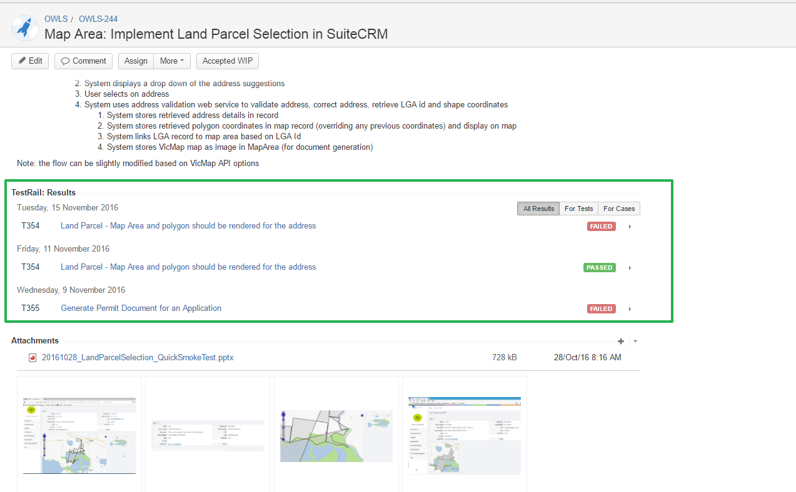

**TestRail to Jira Integration**

The below screenshot shows how the linkage between test cases and defects will be in TestRail

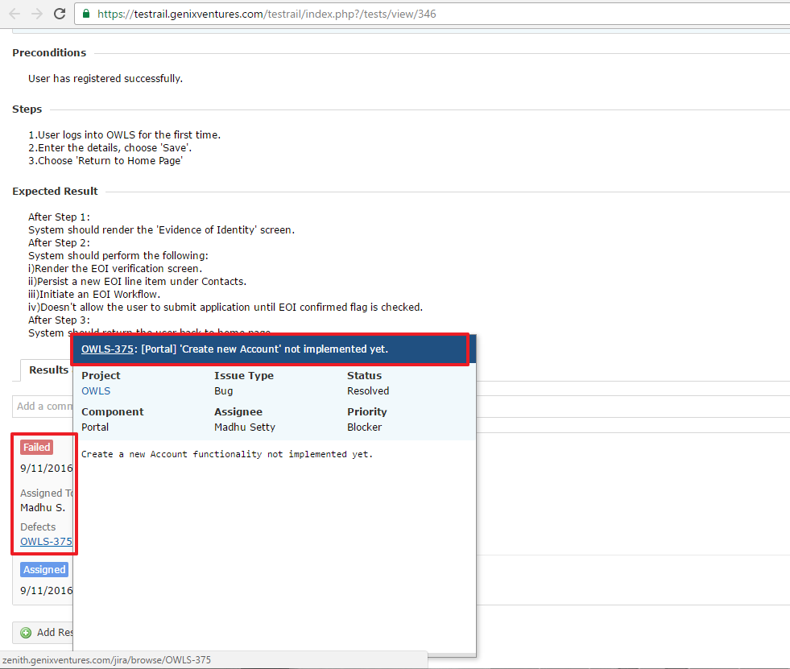

* 1. System Test Entry and Exit Criteria

|  |  |
| --- | --- |
| Entry Criteria | Responsible Party |
| Stage 3 Testing scope document reviewed and agreed before System Test starts | NEC |
| Unit Testing for all delivered functionalities to be completed | Development Team |
| CRM Functionalities made available for system testing from Portal | Development Team |
| Ability for RTO to login and submit the NAT files | Development Team |
| Test Plan for Stage 3 System Testing | NEC System Test Team |
| Test Cases finalized for Stage 3 System Testing in Test Rail on or before the beginning of System Testing. | NEC System Test Team |
| Test data prepared for Stage 3 System Testing and attached to test cases in TestRail on or before the beginning of System Testing. | NEC System Test Team |
| Sanity testing completed by development team and passes all sanity checks | Development Lead |

|  |  |
| --- | --- |
| Exit Criteria | Responsible Party |
| All items under Stage 3 System Testing scope are tested | NEC System Test Team |
| All CRM functionalities execution results are available in the test management tool (TestRail) | NEC System Test Team |
| Test Cases for Stage 3 System Testing along with execution results | NEC System Test Team |
| Test Summary completion report | NEC System Test Team |
| No major/critical outstanding defects in the system. Any open defects will need to be discussed with DET team and decision should be taken | NEC/DET |
| RTM report with Test Coverage | NEC |

Note: Test Entry / Exit criteria for all other types of tests are doucmneted in the Test Startgey.

* 1. Test Signoff
     1. System Testing Acceptance Criteria

Refer to the latest System Test Strategy document for details on this section

* 1. Test Deliverables
* Test cases for Stage 3 System Testing.
* Test case execution results for Stage 3 System Testing.
* Test summary report post Stage 3 System Testing.
* Weekly status report.
* Updated RTM document with Test Coverage
  1. Testing Tools

Refer to the latest System Test Strategy document for details on this section

1. Delivery Stages

Refer to the latest System Test Strategy document for details on this section

1. Test Phases
   1. Sprint Testing

Refer to the latest System Test Strategy document for details on this section

* 1. System Testing

Refer to the latest System Test Strategy document for details on this section

Further to the approach described in the strategy,

* A weekly report listing the activities performed by the test team along with a summary of functionality tested will be submitted to the project team and DET. Any changes to the priority of the raised issues can be notified by DET during this stage.
* At the end of the system testing a detailed report with test case execution results and defects with their status will be circulated to the project team and DET.

A sample Test case execution report will look as shown below:

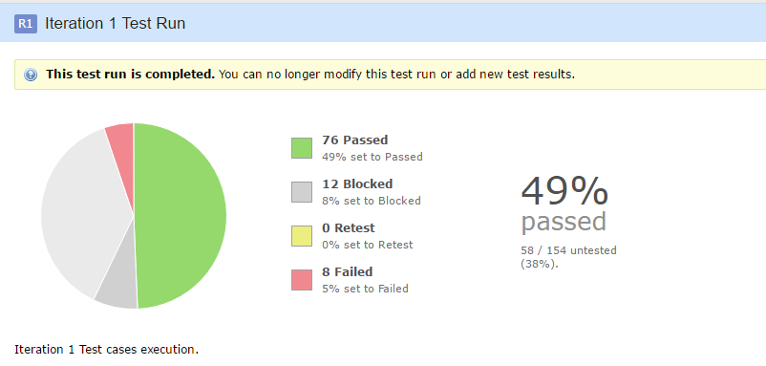

A Defect Summary Report with a list of open defects will be provided at the end of system testing.

**Migrated Data**

As mentioned in **sec 1.8 Constraints** above, data migration is currently “work in progress” and for any system testing that needs migrated data, the below described approach will be employed:

1. For tables that are created in the destination database and populated with data, the test team will refer to/tweak such test data as required
2. For tables that are created in the destination database but not populated with data, testing will done by seeding data into relevant database tables (and modifying the data at a later stage as needed)
3. For tables that are not created in the destination table yet, data cannot be created and hence, the corresponding test cases will be marked as “Blocked”

From a system testing point of view, the process of data management in the test database will be seamless, irrespective of whether testing is done with seeded data or actually migrated data.

However, at the end of data migration phase, system testing team will execute a targeted regression testing of areas that are impacted by the database changes and report any findings

Further, as per the project plan, “Data Refresh will not happen in Stage 3”. Hence, system testing will not be affected as data refresh is not planned in stage-3.

**External Data Sources**

Data Integration with external data sources is currently “Work in Progress”. There are dependencies such as network access, logins etc., that have not been sorted out yet.

As the details about the implementation of the interfaces are not yet available, stubs will be provided to replicate the data in the respective database tables. The system testing team will look up to this data in the database tables. Therefore, data access will be transparent from a testing point of view, irrespective of whether it is being accessed via stubs or interfaces.

However, once the interface connectivity is established, the system testing team will analyse the impact of the changes that occur when the stubs are replaced by real interfaces, execute a targeted regression testing of areas that are impacted by interface connectivity and report any findings, in order to ensure that the data in the database can be consumed in the same way as with stubs and there is no discrepancy in test results when testing with interfaces compared to using stubs

The external data sources are:

**DELTA/EPSILON**

**What it does:** Agreements with Students

**Status:** Currently leveraging the data from SVTS integration with Delta. This data has been migrated from SVTS to VTIS as part of data migration (as SVTS is already interfacing with Delta/Epsilon)

**USI Registry System**

**What it does:** Unique Student Validation

**Status:** A stub has already been implemented. This stub populates the USI Match code field in Student Module.

**TGA**

**What it does:** Organization, Courses, Modules etc Federal Registrar

**Status:** Currently leveraging the data from SVTS integration with TGA.

**STAR / VRQA**

**What it does:** Organization, Courses, Modules etc Federal Registrar

**Status:** Currently leveraging the data from SVTS integration with TGA.

**QAS**

**What it does:** Address Validation for students/RTOs

**Status:** GeoCoding match code in org location and student location module; Currently stubbed

**Pandora**

**What it does:** Student email validation; There are no rules that are dependent on this.

**Status:** Currently stubbed

**ECP**

**What it does:** Provides Single Sign on functionality to the RTOs. ECP integrates with Portal and CRM.

**Status:** Done.

**Accounts Types Required for System Testing:**

**Portal:** A standard account configured as an RTO

**CRM:** An account configured as a DET user

**Database:** A standard user access to database in order to query the database and generate the required test data. This account may also be used to perform data migration testing

Details regarding the account credentials to be used for Data Integration testing are still not available as the approach to Data Integration is yet to be published

NEC has not yet received a view of the TMQ Org structure from DET. Therefore development of roles and system permissions in Portal and CRM is blocked

**Reports:**

Reports that are approved for building by DET and developed by the respective development team will be tested. The below aspects of reports will be tested during system testing:

* Whether report generation criteria are as specified
* Whether the report is loading well and in the expected timeframe
* Whether the fields in the report are correct and satisfy the specifications as well as field validations
* Whether the report data is correct and does not contain any issue such as overlapping data, junk characters, truncating data etc
* Whether any calculations and aggregations in the report are correct
* Whether updates to data are reported correctly (Eg: A course is added and the same should be updated in the corresponding report)
* Whether multiple entry points (if any) to generating the same report are working well
* Whether drill down reports (if any) are working correctly
* Whether the report can be printed and the printed report appears correctly without any truncations/any other issues
* Whether the report can be exported to various formats
* Whether tables, charts etc., are displayed correctly, without any formatting and/or data issues and the same appear correctly when the report is generated in various formats and/or printed
  1. Regression Testing
* Regressiontesting verifies that software previously developed and tested still performs correctly even after it has been changed or interfaced with other modules.
* Before beginning test execution at each stage, system test team will perform an analysis with the Dev team to find out the area which might have been impacted due to the current delivery. Regression Testing will be performed on those identified areas.
* Whenever an issue/bug is fixed, the affected areas will be identified and checked to verify that there are no newly introduced bugs.
* Also, when the system testing is completed, before handing over the system to UAT, a round of regression testing will be performed with a focus on the areas that have undergone a code change
  1. Post-Implementation / Production Verification Testing

Not applicable at this stage.

* 1. Non Functional Testing
     1. Accessibility Testing
* All portal pages will be checked for WCAG 2.0 AA Compliance against the following Accessibility Checklist. This checklist is considered as the test scenarios for Accessibility testing.



* Initial Analysis on the Portal pages were conducted against the above checklist and the outcome is as follows:

1] Images: Should Meet the Requirements   
2] Geospatial: Not Started Development Yet and Not gone through any Dev requirement yet (Not Sure)   
3] Visual Design: -Should Meet the Requirements   
4]: Language-Should Meet the Requirements- Recheck require in current built   
5] Multimedia: N/A   
6] Page Structure: Should Meet the Requirements   
7] Site Structure: N/A   
9] Navigation-Should Meet the Requirements   
10] Forms-Should Meet the Requirements   
11]Tables -Should Meet the Requirements   
12] Scripting- May Require add keyboard events to some existing JS -Should Meet the Requirements   
13] HTML Validation-Should Meet the Requirements

* CRM WCAG compliance has not been agreed as a requirement as yet. However initial Analysis on the CRM pages were conducted against the above checklist and the outcome is as follows.



* Chrome WAVE tool will be used for this verification and only errors reported by the tool will be logged as defects in Jira

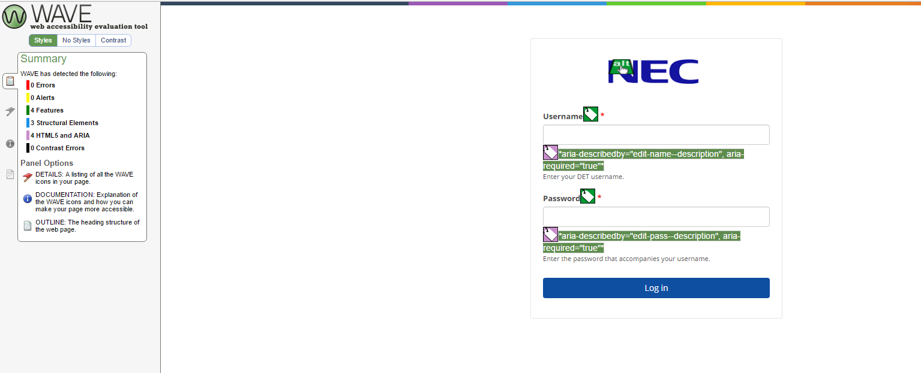

* In addition to Chrome Wave tool HRML source code will be verified to ensure appropriate Accessibility tags and mechanisms are used to ensure that the solution meets the WCAG 2.0 AA accessibility guidelines.
* Application UI colour schemes, logos shared by DET are expected to be WCAG 2.0 AA Accessibility compliant.
* If the UIs of the application are not finalized above accessibility tests will be differed from Stage 3 a later stage till the UIs are finalised.
  + 1. Browser Compatibility Testing

The following list of browsers will be used for System testing of VTIS Portal & VTIS CRM. Test case execution will be spread across the below operating systems and browsers:

* **Windows**
  + IE 11 or later (compatibility mode not supported)
  + Google Chrome – 43 or later
  + Firefox
  + Edge – 26 or later
* **Apple Mac** 
  + Safari 10.0 or later

Please note that CRM based on SuiteCRM COTS product is by default compatible with the following browser versions (Source: <https://suitecrm.com/wiki/index.php/Compatibility_Matrix>).

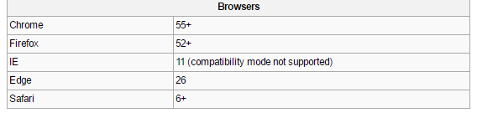

* + 1. Performance Testing

Performance testing is out of scope for stage-3 testing.

1. Environmental Requirements
   1. Environments

The environment provisioned to DET’s UAT team for Stage 1 UAT execution has been assigned as the full-fledged environment for system testing at the end of Stage 1 UAT This environment is hosted on Oracle Private Cloud Appliance (PCA)

Stage 3 System testing will be performed on this full-fledged test environment

* 1. Technical Support

|  |  |  |
| --- | --- | --- |
| Contact | Stream | Email |
| Nicholas Taylor | CRM | Nicholas.Taylor@nec.com.au |
| Owen Mckenna | Portal | Owen.Mckenna@nec.com.au |
| Richard Zhao | OPA | Richard.Zhao@nec.com.au |
| Ryan D’Souza | ETL, CRM | Ryan.D'Souza@nec.com.au |

1. Defect Management

Refer to the latest System Test Strategy document for details on this section

1. Roles and Responsibilities for Stage 3 System Testing
   1. Staffing needs

|  |  |  |  |
| --- | --- | --- | --- |
| Role | Name | Role Description | Offshore resource Location |
| System Test Manager | Yohan Karunathilaka | Test Manager Prepare System Test Strategy, review System Test plan, Walk through of functions to offshore team |  |
| System Test Lead | TBD | Create System Test plan, strategy, design and review test cases, coordinate with project team etc. |  |
| Test Analyst | Shilpa Nerasu | Create System Test plan, design, execute and review test cases. |  |
| Test Analyst | Dilitha Vithanage | Test Case authoring and execution for FS and TS |  |
| Technical Test Analyst | Vivek Chakravarthy | Test Case authoring and execution for FS and TS |  |

* 1. Status Meetings and Reporting

Refer to the latest System Test Strategy document for details on this section

1. UAT Support

Refer to the latest System Test Strategy document for details on this section

1. Risks and Contingencies
   1. Risk and Issue Management

Risks and issues identified as of the writing of this test plan are maintained in the project risk registry and uploaded in Confluence. Click below to download the same: <https://devtools.nec.com.au/wiki/download/attachments/2916413/RAID%20and%20change%20register%2020170531.xlsx?api=v2>

* 1. Lessons Learnt

An analysis of the issues faced during Stage 1 has helped in identifying the below key areas for improving the overall efficiency:

1. Submit test artefacts that are completed from NEC to audit to get feedback, review, incorporate it , and meet the deadlines
2. Improvements to manage testing process, defects and reports, by using advanced features and gadgets provided in Jira
3. Appendix
   1. Acronyms

|  |  |
| --- | --- |
| Acronym | Description |
| CRM | Customer Relationship Management |
| DET | Department of Education and Training |
| NEC | Nippon Electric Company, Limited |
| TMO | Training Market Operations |
| HESG | Higher Education and Skills Group |
| VET | Vocational Education and Training |
| SVTS | Skills Victoria Training System |
| SVBI | Skills Victoria Business Intelligence |
| RTO | Registered Training Organisation |
| OPA | Oracle Policy Automation |
| ETL | Extract, Transform and Load |
| FS | Functional Specification |
| TS | Technical Specification |
| UAT | User Acceptance Testing |
| TMQ | Training Market Quality Division within the Department of Education of Training |